**Puidu Padi Pood**

insert into Items (ItemID, Name, Category, Price, StockAmount)

values(newid(), 'GoodPilow', 'Pillow', 50, 120),

(newid(), 'BadPillow', 'Pillow', 15, 300),

(newid(), 'AveragePillow', 'Pillow', 30, 200),

(newid(), 'BunkBed', 'Bed', 50, 120),

(newid(), 'KingSizeBed', 'Bed', 50, 120),

(newid(), 'Armchair', 'Chair', 50, 120)



insert into Employees (EmployeeID, FirstName, LastName, DepartmentName, Salary, BranchID)

values

(newid(), 'Jake', 'Dog', 'Warehouse Management', 1500, CAST('6351FF6A-F9AE-4E88-B7BC-5963E4DF05C3' as uniqueidentifier)),

(newid(), 'Gary', 'Home', 'Cleaning', 1500, CAST('D17B71AF-8280-480D-919A-6D3A4C0A39A9' as uniqueidentifier)),

(newid(), 'Luke', 'Warm', 'Customer Service', 1500, CAST('95B7EB4A-D581-4DE6-AD21-7E3BD89E711E' as uniqueidentifier)),

(newid(), 'Ash', 'Fire', 'Customer Service', 1500, CAST('95B7EB4A-D581-4DE6-AD21-7E3BD89E711E' as uniqueidentifier)),

(newid(), 'Alice', 'Wonder', 'Warehouse Management', 1500, CAST('6351FF6A-F9AE-4E88-B7BC-5963E4DF05C3' as uniqueidentifier))

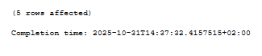

insert into Branches (BranchID, Name, PhoneNumber)

values

(newid(), 'Puidu-Padi Tallinn', 50055005),

(newid(), 'Puidu-Padi Tartu', 50055004),

(newid(), 'Puidu-Padi Pärnu', 50055003),

(newid(), 'Puidu-Padi Valga', 50055002),

(newid(), 'Puidu-Padi Haapsalu', 50055001)

select * from Branches

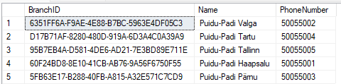

insert into Customers (CustomerID, FirstName, LastName, PhoneNumber, Email)

values

(newid(), 'Shrek', 'Swamp', 55771122, 's@rek.swamp'),

(newid(), 'Leopold', 'Cat', 55771123, 'l@pold.cat'),

(newid(), 'Stone', 'Material', 55771124, 's@tone.material'),

(newid(), 'Derek', 'Friend', 55771125, 'd@rek.friend'),

(newid(), 'Meep-Meep', 'Roadrunner', 55771126, 'm@m.roadrunner')



insert into Sales (SalesID, Date, Total, CustomerID, EmployeeID, ItemID)

values

(newid(), '11.30.2025', 200, CAST('19268CA4-B10B-40A9-A8F2-0FE9B087585E' as uniqueidentifier), -- 1

CAST('65AB1404-71E0-42A6-93A6-8C0F290D84D5' as uniqueidentifier), CAST('61831D06-D83A-4C0E-B55E-C668F291BC34' as uniqueidentifier)), -- 1

(newid(), '11.30.2025', 200, CAST('D2326B67-84FD-4956-874E-B1C514DEDED1' as uniqueidentifier), -- 2

CAST('65AB1404-71E0-42A6-93A6-8C0F290D84D5' as uniqueidentifier), CAST('3777B98A-2F7C-4A2C-B838-CA6C64AEB3DA' as uniqueidentifier)), -- 2

(newid(), '11.30.2025', 200, CAST('8389AD1B-617A-42AC-83E6-C2275234C2AB' as uniqueidentifier), -- 3

CAST('95579E35-BC2A-4433-BAE2-BE8FBB64CF22' as uniqueidentifier), CAST('61831D06-D83A-4C0E-B55E-C668F291BC34' as uniqueidentifier)), -- 3

(newid(), '11.30.2025', 200, CAST('D2326B67-84FD-4956-874E-B1C514DEDED1' as uniqueidentifier), -- 4

CAST('95579E35-BC2A-4433-BAE2-BE8FBB64CF22' as uniqueidentifier), CAST('CAB0D87D-F945-48A4-AA52-F9F3D04AF7AD' as uniqueidentifier)), -- 4

(newid(), '11.30.2025', 200, CAST('E21CCC7F-21C3-4A62-A069-C74BDA39B678' as uniqueidentifier), -- 5

CAST('95579E35-BC2A-4433-BAE2-BE8FBB64CF22' as uniqueidentifier), CAST('EC17F484-8EE5-4804-80EA-CB4BF62E0571' as uniqueidentifier)) -- 5



**Stored procedure**

create proc spSearchEmployeesGoodDynamicSQL

@FirstName nvarchar(100) = null,

@LastName nvarchar(100) = null,

@DepartmentName nvarchar(50) = null,

@Salary int = null

as begin

declare @sql nvarchar(max)

set @sql = 'Select * from Employees where 1 = 1'

if(@FirstName is not null)

set @sql = @sql + ' and FirstName=@FN'

if(@LastName is not null)

set @sql = @sql + ' and LastName=@LN'

if(@DepartmentName is not null)

set @sql = @sql + ' and DepartmentName=@DN'

if(@Salary is not null)

set @sql = @sql + ' and Salary=@Sal'

execute sp_executesql @sql,

N'@FN nvarchar(50), @LN nvarchar(50), @DN nvarchar(50), @Sal int',

@FN = @FirstName, @LN = @LastName, @DN = @DepartmentName, @Sal = @Salary

end

go



**Joins**

select Sales.SalesID, Sales.CustomerID, Sales.Date

from Sales

left join Customers on Sales.CustomerID = Customers.CustomerID

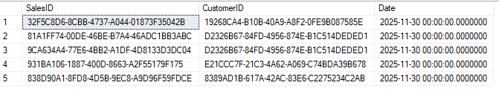

select Sales.SalesID, ItemID, Sales.EmployeeID, Sales.Date

from Sales

inner join Employees on Sales.EmployeeID = CAST('65AB1404-71E0-42A6-93A6-8C0F290D84D5' as uniqueidentifier)

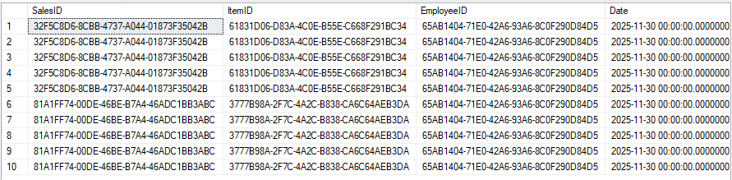

select * from

Employees

inner join Branches on Branches.BranchID = CAST('6351FF6A-F9AE-4E88-B7BC-5963E4DF05C3' as uniqueidentifier)

where Employees.BranchID = CAST('6351FF6A-F9AE-4E88-B7BC-5963E4DF05C3' as uniqueidentifier)

